Merge Sort:

Merging
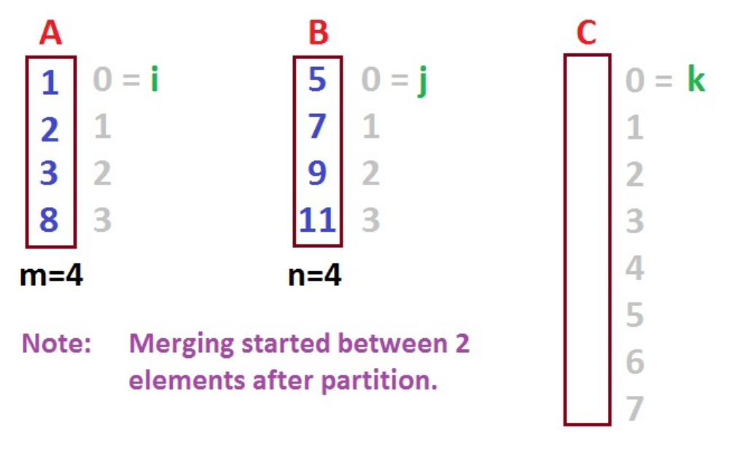
No. of elements in A is 4 and B is 4
m=4, n=4;
while(i < m && j < n) {
if(a[i]<=a[j])
{
temp[k]=a[i];
i++;
k++;
}
else
{
temp[k]=a[j];
j++;
k++;
}
}
while(i<=mid) //Copying remaining elements of left sublist to temp
{
temp[k]=a[i];
i++;
k++;
}
while(j<=h) // //Copying remaining elements of right sublist to temp
{
temp[k]=a[j];
j++;
k++;
}
for(k=i; k<=h; k++)
a[k]=temp[k];
}

Example:

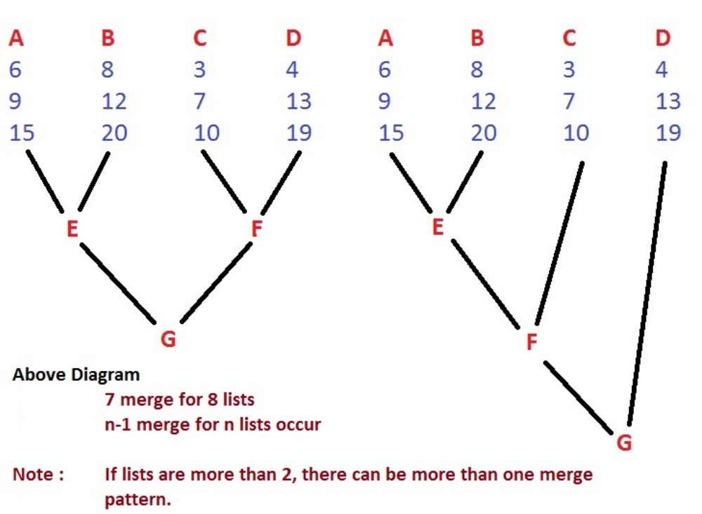

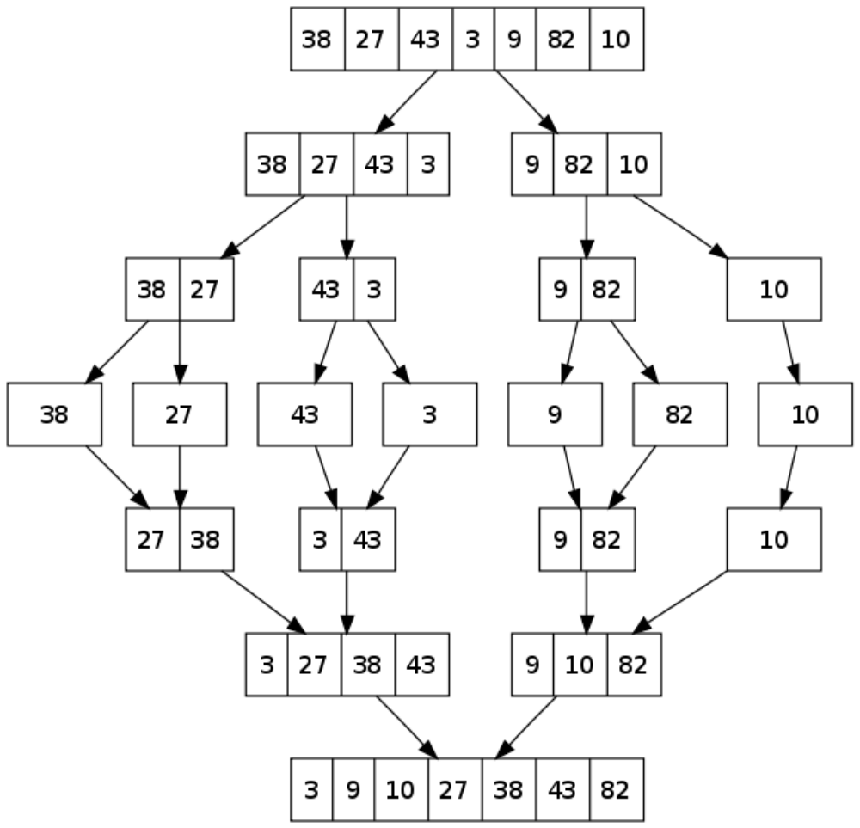

Program for Merge Sort
#include<stdio.h>
#include<conio.h>
int a[10]={24,23,45,65,67,22,47,66,90,87};
void mergesort(int a[],int l, int j );
void merge(int a[], int l, int mid , int h);

void mergesort(int a[10], int l, int h)
{
int mid;
if( l < h )
{
mid = (l+h)/2; // split the list at mid
mergesort(a,l,mid); // first sublist
mergesort(a, mid+1, h); // second sublist
merge(a,l,mid,h); // merging of two sublists
}
}

void merge(int a[10], int l, int mid,int h)
{
int i,j,k;
int temp[10];
k=l;
i=l;
j=mid+1;
while(i<=mid && j<=h)
{
if(a[i]<=a[j])
{
temp[k]=a[i];
i++;
k++;
}
else
{
temp[k]=a[j];
j++;
k++;
}
}
while(i<=mid)
{
temp[k]=a[i];
i++;
k++;
}
while(j<=h)
{
temp[k]=a[j];
j++;
k++;
}
for(k=l; k<=h; k++)
a[k]=temp[k];
}

void main()
{

int i;
clrscr();
mergesort(a,0,9);
for(i=0; i<10; i++)
printf("%d\n", a[i]);

getch();
}

